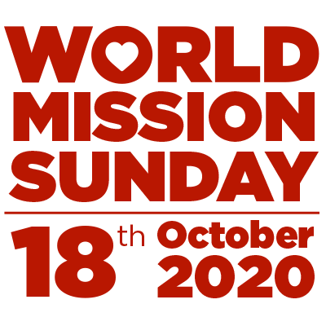
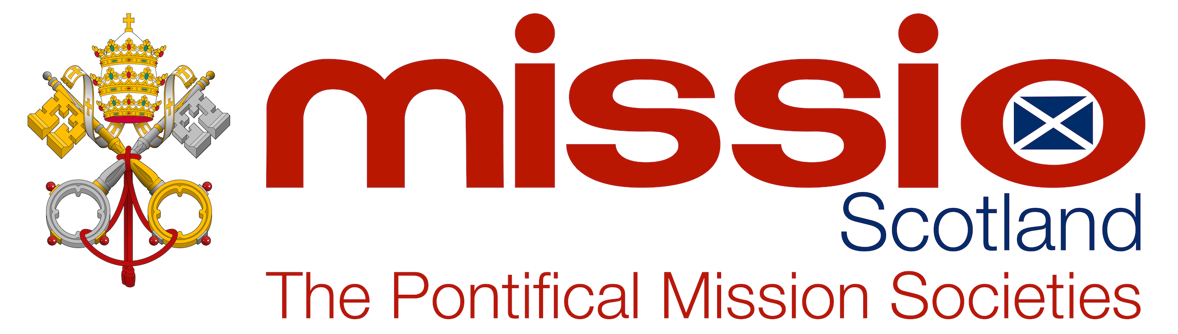

Dear brothers and sisters,

In his message for World Mission Sunday and in his new encyclical, Pope Francis has called all of us to recognise that we are brothers and sisters who have a responsibility for one another.

The terrible reality of the Covid 19 pandemic, he says, should make us recognise that our need for social relationships and our communal relationship with God are deeply connected. The Church is a family.

World Mission Sunday marks a tradition which goes all the way back to the earliest days of the Church where one community helps a Church community in need somewhere else. World Mission Sunday is a day when every person in every parish in every country where the Church is present celebrates together and shares what they have. It is the one Sunday in the year when Pope Francis asks the whole Church to help mission parishes and to reach out with Jesus’ message of hope and love. The Catholics of Scotland have always responded with great generosity to the Pope’s appeal.

In 1988 Fr. Pat Hennessy left his parish of Our Lady and St. Anne’s in Hamilton to go to work among the people of the Andes mountains in Peru, South America. One day some men came to ask him to visit their village higher up the mountain. Among those who would see him was 14-year old Pedro Bustamante. Soon after Fr. Pat’s visit, a parish was established. Several years later Pedro Bustamante entered seminary, was ordained a priest and is now the bishop of Sicuani, a remote area in the high Andes where the people are among the poorest in the world. They have also been hit especially hard by the pandemic.

This year, in your name, Missio Scotland wishes to help the people of Llusco in Sicuani in three ways.

The first is to build a parish house in the village so that there can be a resident priest and the people can have Mass and the sacraments. The house will also be a centre where the community can come together to share food and life.

The second way we can help is to fund a feeding programme for disabled children in the Sicuani area which is run by the diocese.

The third way of helping is to pray for the Church in Peru, especially in Sicuani.

Through whatever you can give this Mission Sunday you can help those who are poor and most in need to experience the love of God. You can donate online by visiting missioscotland.com or by texting Missioscot to 70085 to donate £3.

With the prayers of everyone at Missio for your the health and well-being.

Yours sincerely in Christ,

Fr. Vincent Lockhart
National Director of Missio Scotland – the Pontifical Mission Societies

